Test 1 Geology of NW Europe
20-4-2018, L&R, 09:00-11:00

This test contains 3 open questions (1.5 points each) and 9 multiple choice questions (1/2 point each), giving a total of 9 points. The 10th point for this test comes from the essays on the different countries.
Good Luck!

- Next Sunday, we will depart for our geologic excursion through the Ardennes, Luxembourg and the Eifel, where we will visit several outcrops in order to confront you with different rock types and geologic features that you have learned about during your geology 1 and 2 classes.
What can you tell me about the geology of those regions? Pay attention to the types of rocks you expect to see, how and when they were formed and/or deposited and what tectonic events occurred when and where in these regions. Describe them in chronological order. A map and/or cross section will be highly appreciated.

- Look at this cross section:
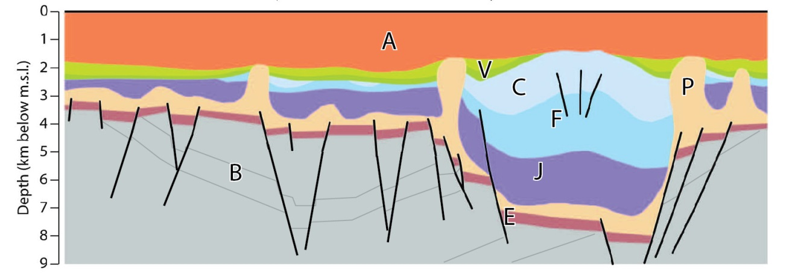
- Where do you think this section is located?
- The chronological order of deposition of these rocks is BEPJFCVA. Between or during deposition of these different packages, certain tectonic events took place. Please list these events, with their relative timing (so between X and Y , or during deposition of Z..).
- Can you give true age and the rock type of the packages B to A?

- Name at least three rocks in the subsurface of the Netherlands (including offshore if you want) that have been very important for the economy of the Netherlands in the past or at present. Describe what they are, how and when they were formed and describe how they have contributed to the economy.

Multiple choice questions. Please note that in most cases, three of the four answers are actually correct, and I am asking for the wrong answer!!

- 4 drill holes from top to bottom, where do you expect a thrust to be present in the subsurface?
- Jurassic, Triassic, Permian, Cretaceous;
- Neogene, Paleogene, Triassic, Permian;
- Holocene, Silurian, Ordovician, Cambrian;
- Cretaceous, Carboniferous, Cambrian, Precambrian;

- Which statement is incorrect?
- The Variscan Orogeny occurred during the Carboniferous and was caused by the collision of Laurasia and Gondwana;
- The Caledonian Orogeny started during the Cambrian and was caused by the collision of Baltica and Laurentia;
- The opening of the North Atlantic Ocean started during the Jurassic, and cuts the Caledonian mountain range in two;
- The Cadomian Orogeny was a small orogenic phase that occurred mainly in Armorica before the Caledonian Orogeny ;

- Which statement is incorrect?
- With extension tectonics, we may observe the following structures: normal faults, metamorphic core complexes, synthetic faults and detachment;
- With contraction tectonics, we may observe the following structures: dipping fold axis, domino faulting, blind thrusts, mountain building;
- With strike-slip tectonics, we may observe the following structures: pull apart basins, Riedel faults, anticlines, horizontal slickensides;
- With salt tectonics, we may find the following structures: anticlines, diapirs, detachment, salt glaciers;

- Who sees things that are not there?
- Student A finds an oil field in the Brent Sandstone;
- Student B finds coral reefs in the Ardennes;
- Student C finds basalt in the Eifel;
- Student D finds a dinosaur fossil in Finland;

Please turn page

- Which series of terms contains one that does not belong?
  - Antithetic, Relay ramps, Riedel, Flower structure;
  - Silurian, Triassic, Neogene, Proterozoic;
  - Coal, Kimmeridge, Brent, Posidonia;
  - Hercynian, Caledonian, Cadomian, Variscan;

- Which is wrong?
  - The Alps were formed by the collision between Africa and Europe , which started in the Cretaceous and is still ongoing;
  - The Alps consist of two parts: the Southern Alps where rocks were displaced towards the south, and the Northern Alps where rocks were displaced toward the North and West;
  - The Northern Alps in turn consist of three large nappes (thrust sheets) stacked on top of each other, from top to bottom the Autroalpine, the Penninic and the Helvetic nappes;
  - Of these three, the Helvetic nappes shows the highest metamorphic grade, because they were buried the deepest;

- Which is wrong?
  - Contraction is a process that is generally caused by lithospheric plates sliding past each other;
  - If oceanic crust is involved in the collision, it will usually be subducted under continental crust and recycled in the mantle;
  - During the collision, parts of the oceanic crust may not be subducted and end up in the resulting mountain range, where we call them ophiolites;
  - Typical rocks found in ophiolites include pillow basalts, gabbros and sheeted dikes;

- With strike slip tectonics:
  - σ₁ is horizontal and σ₃ vertical;
  - σ₂ is horizontal and σ₁ vertical;
  - σ₃ is horizontal and σ₁ vertical;
  - σ₁ is horizontal and σ₃ is too;

- which contains a term that does not belong?
  - Paris, Aquitaine, North Sea, Molasse
  - Rhine, Rhone, Central, Viking
  - Armorica, Massif Central, Vosges, Harz
  - Pyrenees, Alps, Ardennes, Jura

