Test Geology of NW-Europe AESB1230
12-12-2014, 8.45-9.30, zaal E CiTG

- “The present is the key to the past” is an important assumption within geology. Who formulated this assumption, what did he mean, and what were the consequences of this assumption? What were the principles of Steno?
That was James Hutton. He meant that the processes that occur now and that we can observe must have been active in the past too. This also meant that since these processes were very slow, that he needed a lot of time to form the world around him, especially after he visited the unconformity at Siccar Point. This meant that the earth was far older than what the church claimed.
Steno's principles: original horizontality, superposition (young on top of old) and lateral continuity
- Give an overview of the main periods of the Paleo-, Meso- en Cenozoic, including their rough ages.
Well, most of you had no problems here. There were a few that missed this question, clearly they either did not study, or they were never present (or asleep) during class.
- Draw a schematic cross section of the lithosphere to explain the mechanism of plate tectonics.
This is more or less what I was after:

I definitely wanted to see different thicknesses for the oceanic and continental crust, the fact that the crust and the top of the mantle together form the lithosphere, that continents can break too, that oceanic crust is formed from solidifying mantle material, subduction, trenches, island arcs and at least one orogen. Some of the results were OK, some were appalling, showing no understanding of plate tectonics whatsoever....
- A sandstone sample in a bench press is subjected to a confining pressure of 200 MPa. This particular sandstone has an angle of internal friction of 25º, and a cohesion of 100 MPa. We now increase the axial stress until the sample breaks. At what value of axial stress do you think the sample will break, and what do you expect the angle of the fault will be relative to the axial stress direction?
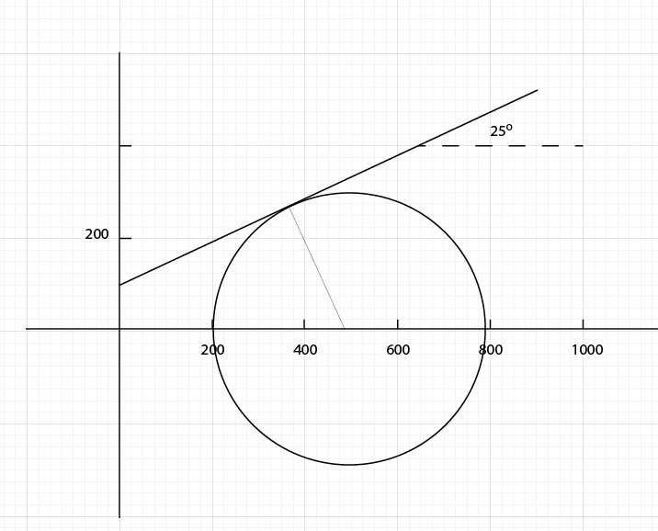

sigma3 = 200, as you can see you can raise the axial pressure to about 800 MPa before the rock will break.
2Theta will be 115 degrees in this case, so theta is 57.5 (angle between sigma1 and sigma n) so the angle between sigma 1 and the fault plane will be 90 - 52.5 = 32.5 degrees
- What are the similarities and differences between faults and fractures, and what are their effects on fluid flow in a reservoir? Fractures can have different origins, what are they? In a drawing, illustrate the relation between the different fault types (normal, thrust and strike slip) and their orientation relative to the direction of the principal stresses.
Similarities: both are caused by stress larger than the rock strength, both are a form of brittle deformation, and both break the rock
Differences: with a fault there is movement along the fault plane, with a fracture there is not. In general, faults offset the layers, while fractures are confined to the layers. There's more, but these are the important ones.
Influence on fluid flow: in general, fractures enhance fluid flow, faults restrict it, because they break up the reservoir in smaller compartments. Of course, exceptions to this do exist.
Origins of fractures: regional stresses, cooling, uplift, around faults and around folds.
Relation faults and principal stresses: variations on the figure below can be found in the powerpoints. S means sigma in this figure
Please note that the fault plane is ALWAYS at an angle of roughly 30 degrees to sigma one, so NEVER parallel to either sigma 1 or sigma 3.
Also note that all figures are effectively the same, but just rotated over 90 degrees with respect to the other ones

