Period | Sedimentology | Climate | Economically importance | Deformation
Cambrian  541 – 485 Ma | Mainly deep water deposits | (Greenhouse) |  | Avalonia detaches from Grondwana and moves North
Ordovician  485 – 444 Ma | Mainly marine sedimentation (sandstones, shales) | Plants move out of the sea |  | Subduction along Laurentian shores -> volcanic activity.  Upper Ordovician: collision between Baltica and Avelonia
Silurian  444 – 416 Ma | Marine conditions: often black shales (&sandstones) | (Icehouse) |  | Plates start colliding -> lapetus ocean closes  Caledonian Orogeny starts
Devonian  417 – 354 Ma | First deposition of a lot continental deposits, with rising sea level more deeper marine deposits like shales and limestones.  Pre-Devonian rocks strongly deformed, stronger towards the North.  Continental in North, ‘old red continent’ | During the Devonian the sea level changes.  Shows trans-regressive cycle in the South:  Sand-shale-limestone-shale-sand.  Mass extinction in the end.  (Greenhouse) | Is seen as one last exploration possibilities by the oil industry, but so far unsuccessful. | Transitional phase between Caledonian and Hercynian Orogenies.  Variscan plate slowly moving north
Carboniferous  354 – 299 Ma | Hercyian orogeny has big influence on sedimentary development. Sedimentation very fast due to emerging mountains in south. Sediment change from marine to continental. During the Upper Carboniferous the Basin is cut off from ocean, becomes continental. | Plants conquered the continent. NW Europe on Equator, transgression since Devonian.  NW European basin becomes smaller -> Large swamp with tropical forest start to develop.  (Starts with Greenhouse and ends with Icehouse) | Rainforest -> coal. (Limburg, Ruhr, Belgium, Wales).  Source rock for natural gas (Groningen) | Hercynian/Variscan Orogeny
Permian  299 – 252 Ma | Rotliegendes (Lower Permian) is important gas reservoir in NW Europe.  Zechstein evaporates (Upper Permian) seal for gas reservoirs. | Globally icehouse, low sea level. NW Europe in tropical conditions. Originally desert with wadi’s and sand dunes. Later in land sea with very high evaporation.  (ends with Greenhouse) |  | One Large continent: Pangea.  Two basins: Northern Permian Basin and Southern Permian Basin.
Triassic  - – 201 Ma | * Buntsandstein (Lower): Aeolian, fluviatile, playa  * Muschelkalk (Middle): Shallow marine limestones, marls and evaporates, regressive sequence ending in Keuper  * Keuper (Upper): very shallow water to dry, clastic and evaporates. | Warm and arid climate | Buntsandstein important as reservoir rock and in construction.  Muschelkalk also used in construction.  Röt evaporates (Halite) is mined in the Netherlands (Twente) | Epicontinental basin, start rifting phase.  Rifting starts from end Buntsandstein
Jurassic  201 – 145 Ma | London Brabant Massif remains above sea level, as old Caledonies -> source of sediments.  Deposition of large shales in large parts of NW Europe.  Deposition of Posidonia Shale, Kimmeridge Clay and Coevorden Fm.  Depostion of Brent and Delfland.  Limestone in Paris Basin.  Marls and limestone in SE France. | Transgression | Posidonia Shale, Kimmeridge Clay and Coevorden Fm important oil source rocks.  Brent and Delfland reservoir rocks.  Luxemburg sandstone and Luxemburg Minette iron ore. | Pangea starts to fall apart into Laurasia and Gondwana.  Formation rift basins North Sean & North Atlantic  Rhine Graben fromed.  Extension in NW Europe.
Creataceous  145 – 66 Ma | Lower: Brentheimer sandstone  Middle: Shales, beginning of limestone deposition  Upper: Little erosion, massive limestone deposits worldwide (Chalk).  Depositions of coastal sands in North Sea Areas | Lower: Regression in NW Europe  Middle: Transgression  Upper: Very warm, transgression  (Greenhouse) | Brentheim sandstone important reservoir e.g. Schoonebeek oil reservoir. | Extention continues, strong subsidence in North Sea Basin.  Rifting starts in N-Atlantic  Iberia collides with S-France.  Alpine Orogeny starts  Inversion at start of Tertiary
Cenozoic  66 Ma – present |  | Meteorite impact New Mexico -> Extinction  Almost continuous drop of sea level  (Icehouse) |  | Inversion in the Netherlands, related to continued deformation in the south of Europe.
Eocene  56 – 34 Ma | Clastic sedimentation in North Sea | Most of NW Europe above sea level. |  | Atlantic has opened.  -> Volcanic activity in Scotland/Ireland.  Balkans, Carpathians and Pyrenees formed  Subsidence in North Sea.  Rhine Graben starts forming
Oligocene  34 – 23 Ma |  | UK dry, North Europe & Paris shallow seas |  | Spain more or less in position.  Alps start to form.  Rift through W-Europe  Volcanic activity starts in Massif Central.  Uplift of the Ardennes.
Miocene  23 – 5 Ma | Large delta forming in North Sea area |  | Silversand mining (S-Limburg)  Lignite (Germany) | Alps start to form in earnest. Sea floor spreading in Mediterranean  Ardennes-Eifel area starts to uplift.  Volcanic activity in Eifel and Massif Central.  Paris Basin starts to close.
Conclusion of Tertiary | Clastic sedimentation in NW Europe | Fall of average temperature.  Ends with Ice ages, caused by combination of tectonics and milankovic cycles. |  | Starts with inversion of Mesozoic basins.  Volcanism in Ireland/Scotland, Eifel, Massif Central and Rhine Graben.
Pleistocene  2.6 – 0.01 Ma |  | Ice ages
Holocene  0.01 Ma – present | Coastline hardly changed last 6000 years because sand was added by sea and rives.  The river channel belts constantly changed during the Holocene due to avulsion. | * Sea level has risen over 50 meters since last ice age; on average 50 cm/1000 y (decreasing in time)  - Present prediction by KNMI is 30 – 90 cm in next century  * Temperature rise last 10,000 y was ~0.15°C/century  - Predictions next century ~2 – 6 °C rise

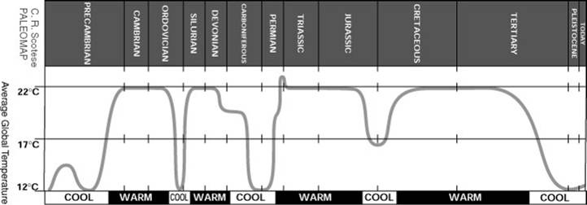
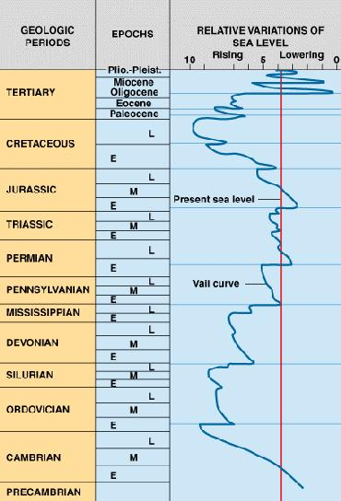
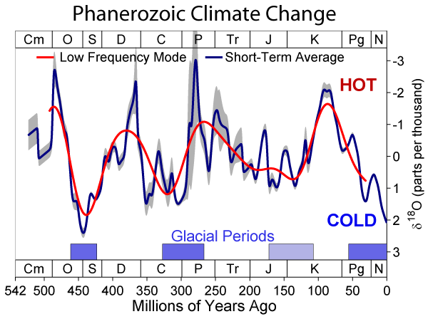
Green
House
Green
House
Green
House
Green
House
Ice
House
Ice
House
Ice
House

